Basic Statistics-1

#### Descriptive Analytics for Numerical Columns

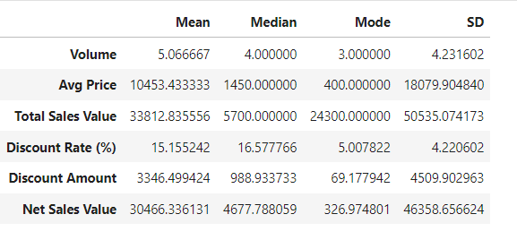

**Interpretation:**

* **Mean**: Represents the average value for each column. For instance, the average price of an item is approximately 10,453.43 units.
* **Median**: Indicates the middle value when the data is sorted. For example, the median discount amount is 988.93 units, which means half of the discounts are below this value.
* **Mode**: The most frequently occurring value in the data. For example, the most common Volume is 3.
* **Standard Deviation**: Measures the dispersion of data from the mean. A higher standard deviation, like in Total Sales Value, indicates more variability in sales figures.

**Python Code:**

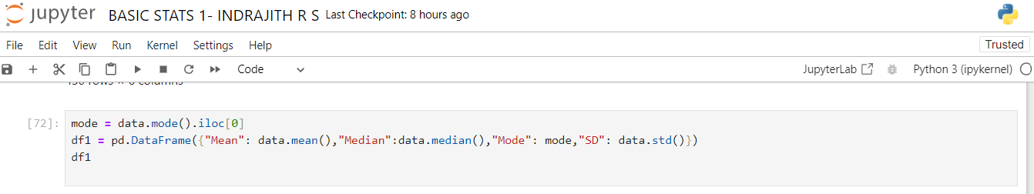

#### Data Visualization**:**

**Histograms:**

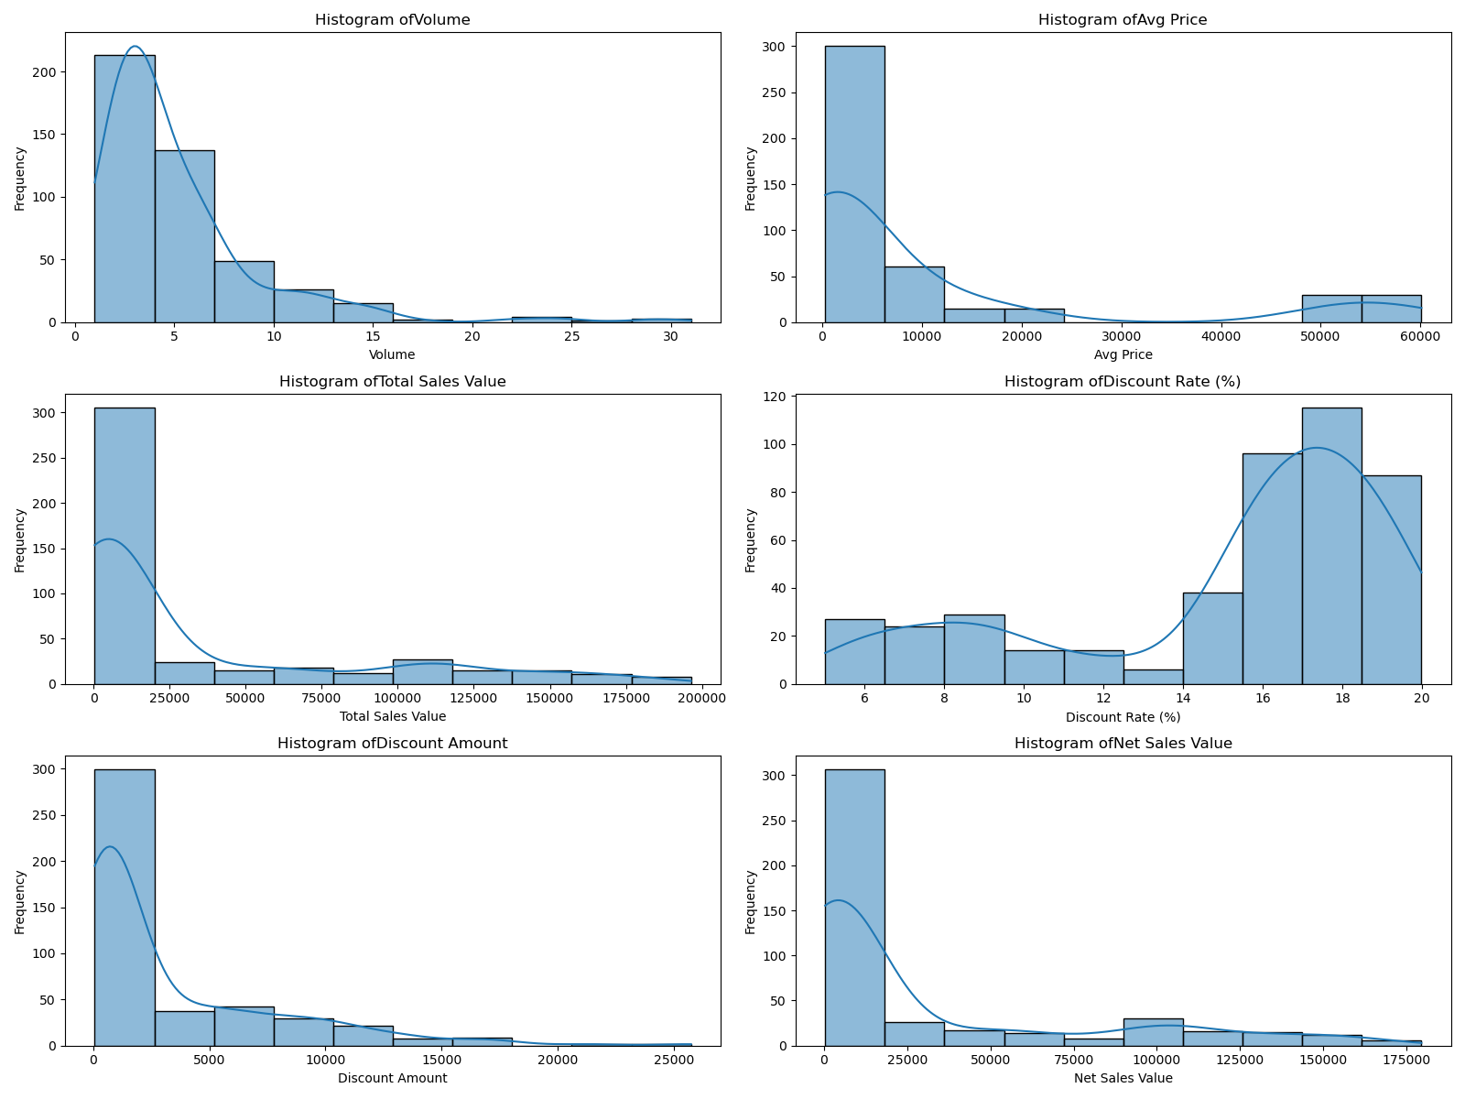

**Interpretation:**

The distribution of columns ‘Volume’, ‘Avg Price’, ‘Total Sales Value’, ‘Discount Amount’, ‘Net Sales Value’ are right-skewed and ‘Discount Rate (%)’ is left-skewed.

All these column distributions contain outliers

**Python Code:**

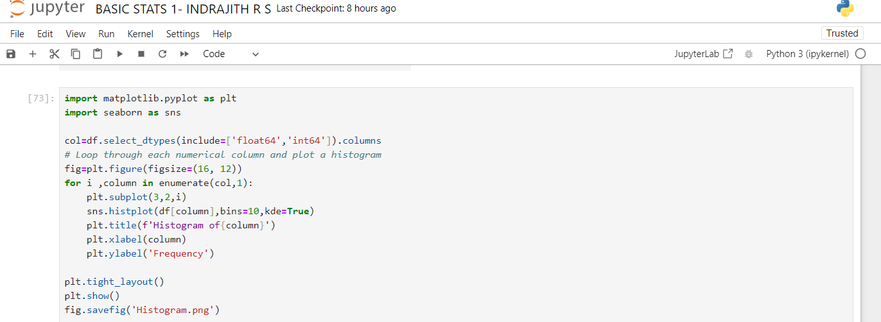

**Boxplot:**

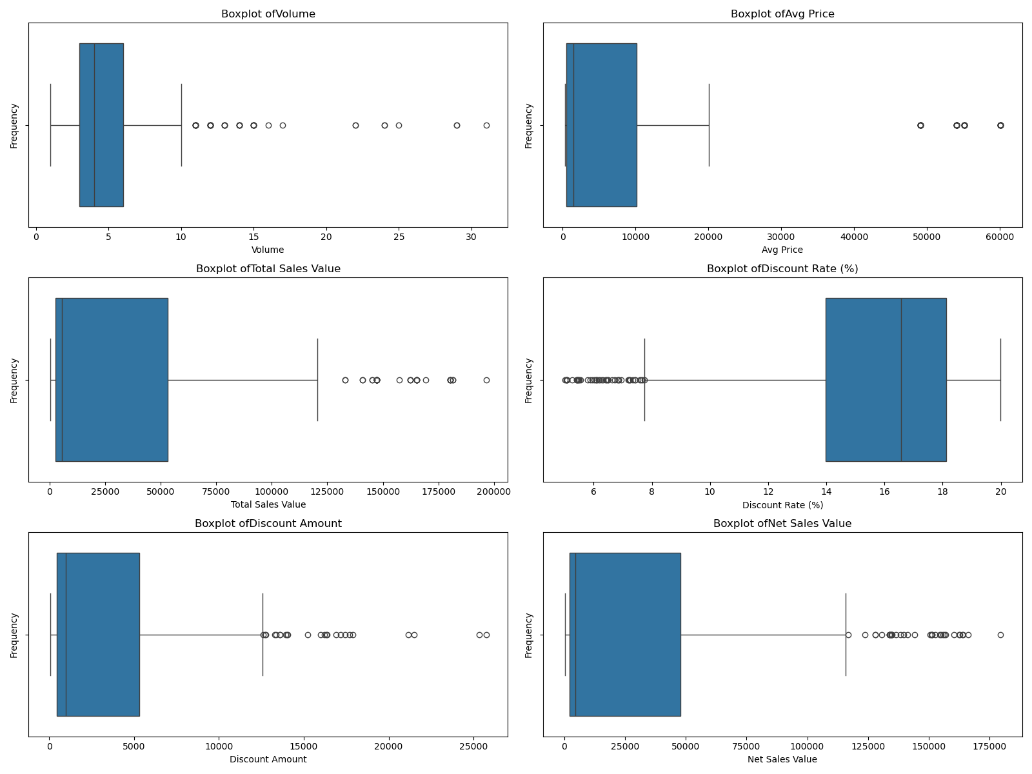

**Interpretation:**

Volume: There are numerous outliers in the volume data. many values exceed this limit, indicating potential extreme values. Significant outliers suggest variability in volume data.

Avg Price: The average price has several extreme values well beyond the upper bound. Repeated high values likely indicate data entry errors or unusual pricing.

Total Sales Value: The total sales value has several outliers, indicating extreme sales figures. Several high sales values suggest variability in sales performance.

Discount Rate (%): There are several outliers in the discount rate, mainly on the lower end, indicating discounts below the usual range. This suggests that while most discounts fall within a typical range, some are significantly lower.

Discount Amount: The discount amount has numerous high outliers, indicating several large discounts. These high values suggest that while most discount amounts are within a reasonable range, there are instances of significantly higher discounts.

Net Sales Value: The net sales value column has several high outliers, indicating large sales figures. This suggests that while most sales values are within a typical range, there are instances of significantly higher sales.

**Python Code:**

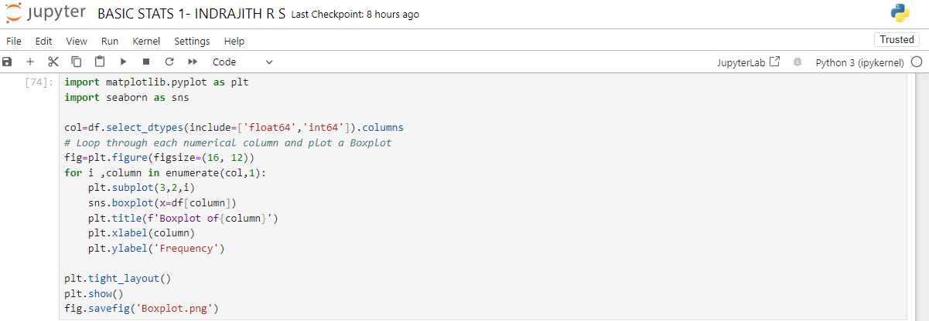

**Bar plot:**

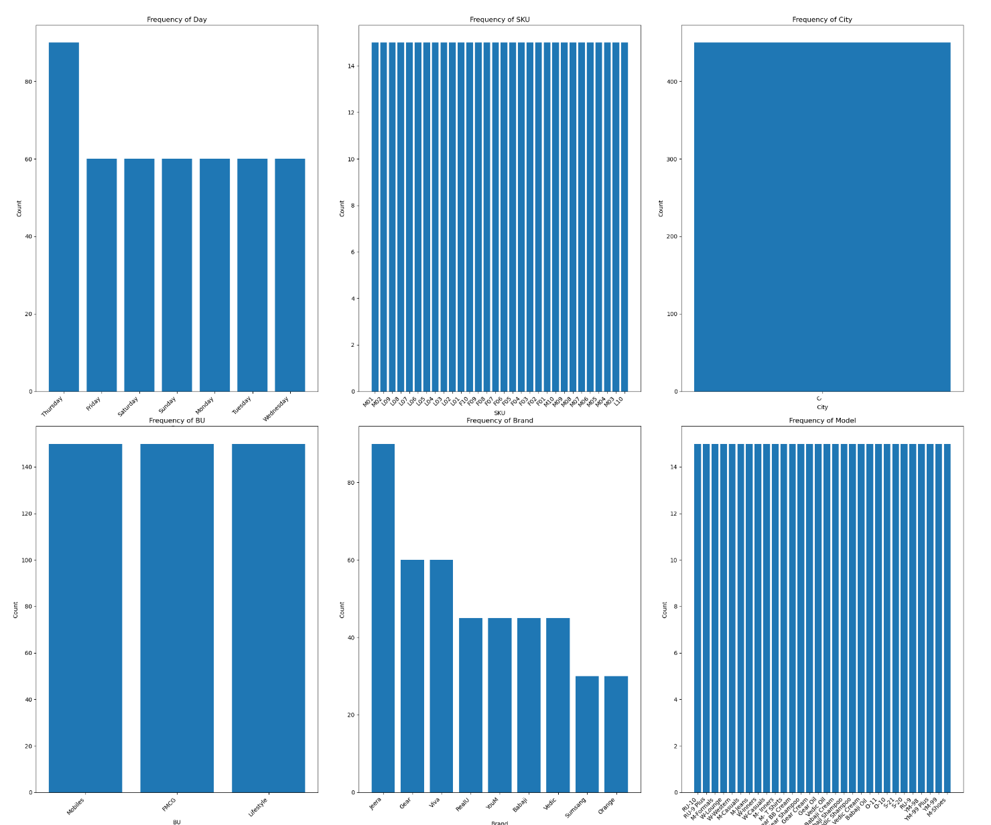

**Interpretation:**

* Activity is concentrated towards the end of the week, especially on Thursdays.
* SKUs and Models are evenly distributed, suggesting a balanced product or model offering.
* The "C" city dominates the dataset, possibly indicating that only one location's data is being analyzed.
* Business Units related to Mobiles and FMCG are more active than Lifestyle.
* Jeera is the most frequent brand, with Sumsang and Orange being less frequent.

**Python Code:**

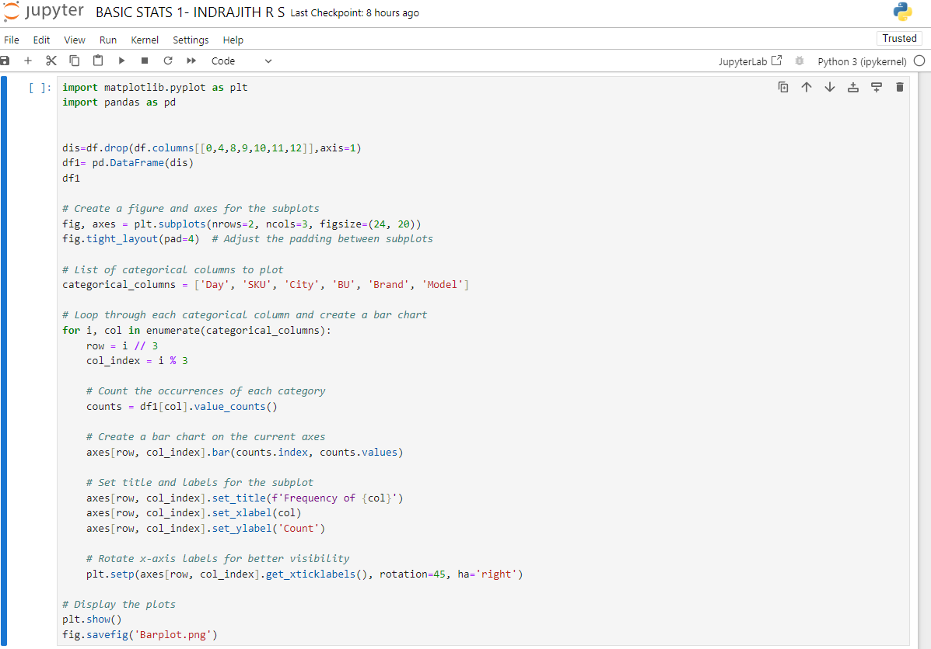

*Standardization of Numerical Variables:*

Data standardization (Z-Score Normalization) is a preprocessing technique used to rescale features in a dataset so that they have a common scale. The goal is to ensure that all features contribute equally to a machine learning model, especially when they have different units or scales.

**Formula:**

$$Z= \frac{X-μ}{σ}​$$

Where:

* X is the original data point (feature value).
* μ is the mean of the feature.
* σ is the standard deviation of the feature.
* Z is the standardized (or z-score) value.

**Before and after standardization comparison:**

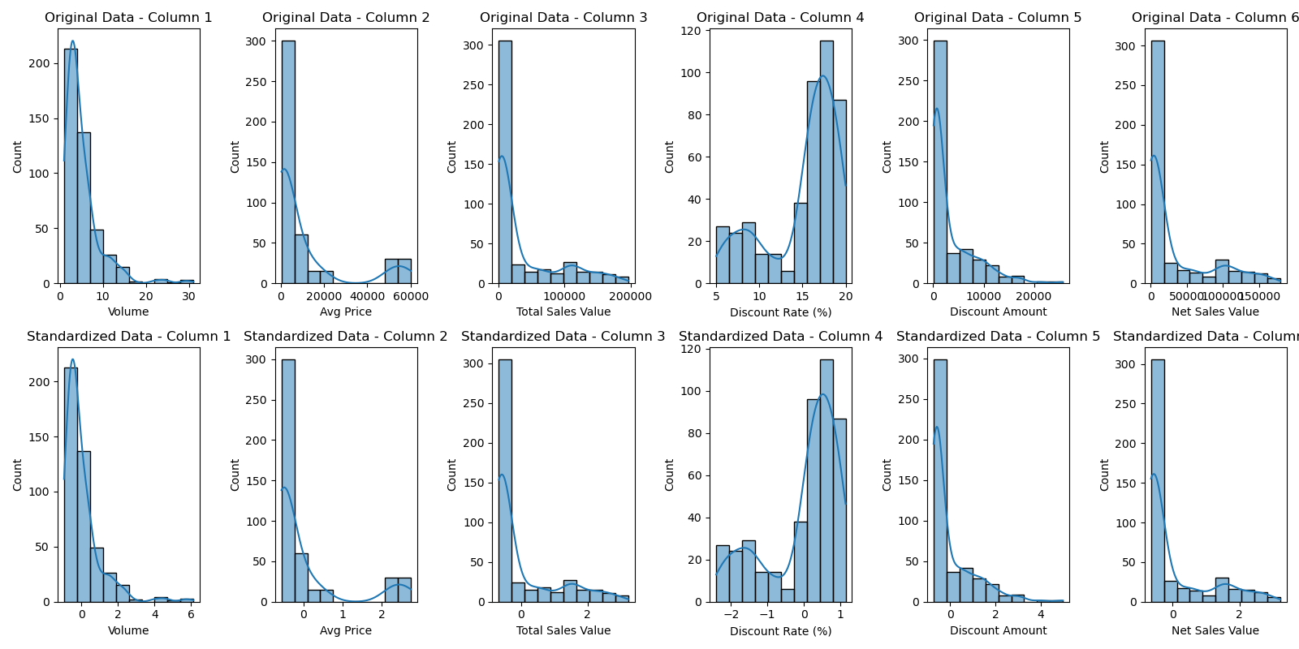

*Conversion of Categorical Data into Dummy Variables:*

Converting categorical data into dummy variables (one-hot encoding) is necessary because many machine learning algorithms require numerical input and cannot handle categorical data directly. One-hot encoding transforms each category into a binary column (0 or 1), ensuring that no unintended ordinal relationship is implied between categories. This method makes categorical data suitable for models like regression, decision trees, and neural networks.

